Examples 10K and 10Q reports
Platforms & How to Find the Reports
Platform | How Reports Are Presented | Steps to View Them
TD Ameritrade (brokerage firm) & thinkorswim - trading platform (desktop, web, and mobile) that TD Ameritrade developed | 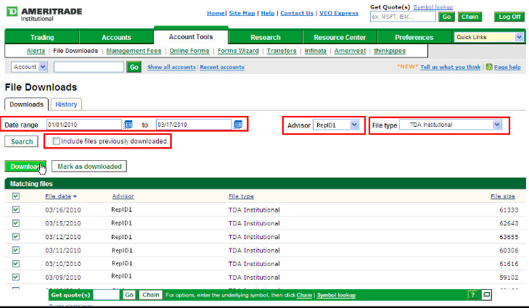 | 1. Log in to your TD Ameritrade account.  2. Go to the “Research” tab or “Investor Relations” section.  3. Find “SEC Filings” (sometimes under “Company Info” or “Financials”).  4. Search by company ticker or name.  5. Click the 10-K or 10-Q link to view/download PDF/HTML.
Fidelity (Investment and brokerage firms) | 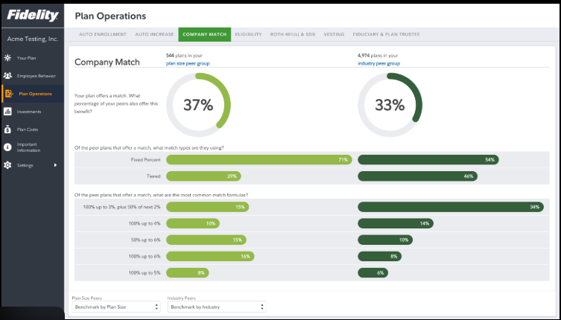 | 1. Open Fidelity’s website or app.  2. Navigate to a company’s profile (search the ticker).  3. Look for “Financials,” “SEC Filings,” or “Resources / Documents.”  4. There you will see 10-Q (quarter‐by‐quarter) and 10-K (annual) reports listed.  5. Click to open PDF or HTML or download.

